1. Design the logic for a program that allows a user to enter 20 numbers, then display them in the reverse order of entry. Present a flowchart diagram file (.jpg) and a text file for the pseudocode (.txt).

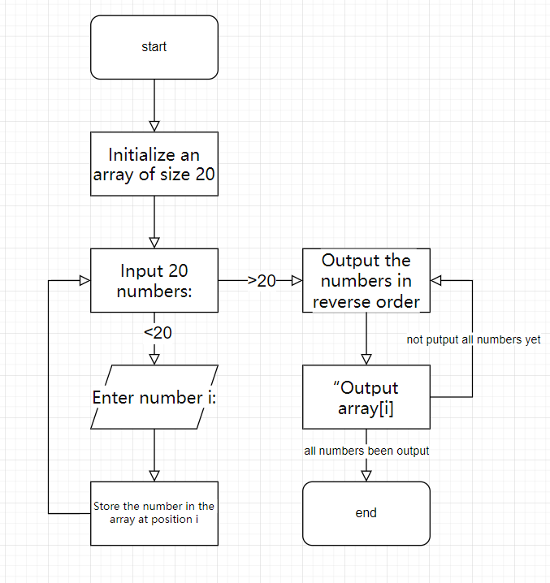

Code in Practice Exercise Chapter 6.txt